START-UP BEHAVIOR OF VISCOELASTIC FLUID FLOW NEAR A CAPILLARY ENTRY

Yosuke ARUGA*， Atsushi WATANABE**， Tsutomu TAKAHASHI* and Masataka SHIRAKASHI*

* Department of Mechanical Engineering, Nagaoka University of Technology, 1603-1 Kamitomioka-machi, Nagaoka, Niigata, 940-2188 Japan.
** Toray Engineering Co.Ltd., 3-3-16 Hongoku-cho, Nihonbashi, Tokyo, 103-0021 Japan.

INTRODUCTION

A flow near a die entry or in an abruptly contracting pipe flow is one of flows where elasticity of fluid can have dominant effect because a fluid element is elongated unsteadily even when the flow field itself is steady. Due to its practical importance, many works have been carried out on viscoelastic fluid flows in a contracting channel, mainly on steady flows. This investigation is focused on the effect of elasticity on the development process of a capillary entry flow where the influence of side-walls of the upstream large channel is negligible.

EXPERIMENTAL

Figure 1 shows the geometry of the test section channel and the coordinate system used in this paper. A capillary with a diameter d=2mm and a length L=157mm is attached flush to the bottom of the upstream large reservoir. Since the contraction ratio is virtually infinite, influence of the side-walls of the upstream reservoir can be taken to be negligible.

An aqueous solution of polyacrylamide with 0.2 wt% concentration (PAA-solution) is used as the test fluid. A rice-syrup/water mixture is used as a Newtonian fluid for comparison. A cone-plate type rheometer is applied to obtain their material functions in the steady simple shear flow. The shear viscosity and the first normal stress difference of the PAA-solution thus obtained are shown in Figure 2. Since the viscosity is well represented by the power-law model, the generalized Reynolds number Re* is estimated for the developed capillary flow by applying the power-law for the viscosity. The range of Re* in this experiment is 0.8 - 90.

In an experimental run, the fluid filling the test section was kept at rest for a while under a pressure of compressed air or natural head, and then a valve below the capillary was quickly opened to start the flow. The driving pressure was kept constant during a test run.

The tracer-particle and light-sheet technique is applied to visualize the flow. A two-component LDV is used for velocity measurement in the x-z plane. The flow rate Q and the pressure drop through the capillary are also measured simultaneously.

RESULTS AND DISCUSSION

The flow pattern of the Newtonian rice-syrup/water mixture is shown in Figure 3, compared with the velocity vectors obtained by the LDV measurement. The exposure time for the photograph is from t = 0 to t = 9s. Results as shown in this figure and measurements on the flow rate and pressure drop show that the development of the flow field of a Newtonian fluid upstream the capillary entry is virtually quasi-steady at a Reynolds number in the range of this experiment, i.e. the flow pattern with radial streamlines as shown in Figure 3 develops immediately after the flow started and the absolute values of velocities increase proportionally with the flow rate Q till it attains its terminal value Q∞. The flow rate Q increases monotonously and the transient time t_{tr} for Q is very short, say less than 0.5 s, in contrast with the case of the PAA-solution as described in the following sections.

The normalized flow rate Q/Q∞ of the PAA-solution is plotted against the non-dimensional time t/λ in Figure 4. The relaxation timeλand the Weissenberg number We are calculated by applying the Denn model for the developed capillary flow based on the material functions in Figure 2 [1]. The transient time t_{tr} for the PAA-solution is quite long, e.g. t_{tr} =7s at We=4.1, and t_{tr}/λ is almost independent of We. A very large over-shoot of flow rate is observed and the maximum value of Q/Q∞ is seen to increase with We in the experimental range of this work.

The axial and the radial components of velocity, v_{z} and v_{r}, on the centerline upstream the capillary entry is shown in Figure 5. The measurement is carried out simultaneously with the Q for We= 4.1 in Figure 4. The delayed development and the overshoot behaviors are observed in v_{z} corresponding with Q. However, the relative value of maximum overshoot is considerably lower than that of Q, meaning that the pattern of streamlines changes during the transient stage.

Instantaneous flow patterns and velocity fields in the transient stage are compared in Figure 6. The flow pattern just after the start of flow is similar to that of a Newtonian, and then the angle of the flowing region where the velocity vector is pointing towards the entry decreases with time. The size of the vortex surrounding the flowing region grows gradually till the terminal developed flow field is established. The transient behavior of the flow rate is considered to be caused by the entry pressure loss which depends on the flow pattern upstream the entry.

CONCLUSIONS

While the developing process of capillary entry flow of a Newtonian fluid is virtually quasi-steady, it takes a considerable time for a viscoelastic fluid to attain its terminal regime. The transient time for the PAA-solution non-dimensionalized by the fluid relaxation time is independent of the Weissenberg number, but the flow rate overshoot ratio is seen to increase with We.

The flow pattern upstream the capillary entry determines the elongation rate, which governs the elongation stress at the entry, and the entry pressure loss in turn. Hence, the transient behavior of the flow rate is attributed to the gradual development process of the flow field upstream the entry.

REFERENCES

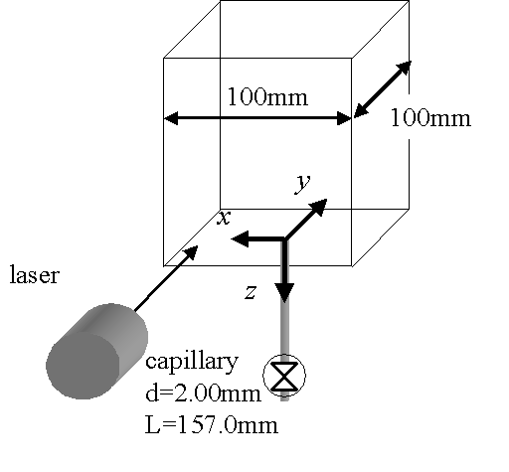
[1] D.V. Boger and K. Walters, Rheological Phenomena in Focus, p.7, Elsevier, 1993.

Figure 1 Flow channel and the coordinate system
LDV

170mm
Compressed air.
P₀
Laser
Capillary

Figure 2 Material functions of the PAA-solution
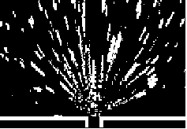
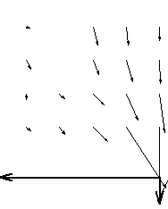
Figure 3 Flow pattern of the rice-syrup/water mixture
( Re = 0.8 )
0
10mm
Figure 4 Transient behavior of flow-rate of the PAA-solution
● We = 3.4
■ We = 4.1
◆ We = 5.5

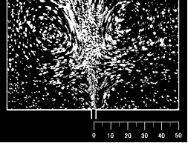
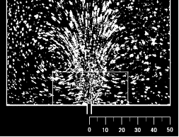
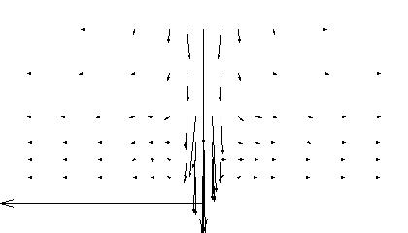
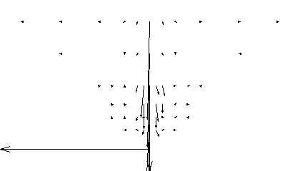
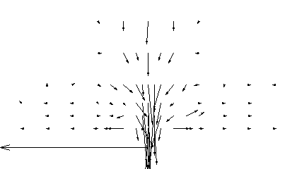
Figure 5 Transient behavior of velocity of the PAA-solution
( We = 4.1 , z/d = - 5 , x = y = 0 )
10d
0.02 m/s
・
・
10d
0.01 m/s
・
・
・
・
・
・
・
・
・
・
・
・
・
・
・
・
・
・
・
・
・
・
・
・
・
・
・
・
・
・
・
・
・
・
・
・
・
10d
4 mm/s
・
・
・
・
・
・
・
・
・
・
・
・
Figure 6 Development of flow field of the PAA-solution ( We=4.1)

t =2.0s
t =7.0s
ｔ = 0~5s
t = 7~12s
t =0.5s
(mm)
(mm)

