PIV MEASUREMENT AND NUMERICAL ANALYSIS OF THE NEW REFRIGERATION COMPARTMENT OF THE LG’S SIDE BY SIDE REFRIGERATOR

S.H. CHO, I.S.LEE, J.Y.CHOI, Y.S.NAM
Core technology team, Digital Appliance Research Laboratory, LG Electronics Inc.
327-23, Gasan-Dong, Keumchen-Gu, Seoul, Korea

The LG side by side type refrigerators use a single evaporator, and a single fan to cool the freezer and refrigerator compartments. The high-temperature, high-pressure refrigerant flows through the evaporator, cooling the surrounding in the process, and the cool air is distributed into the freezer and refrigerator compartments according to a prescribed volume ratio. The cool air flowing into the refrigeration compartment passes through the damper insulation and out of the front and rear outlets. Once the refrigeration compartment is cooled to a prescribed temperature, the temperature is controlled by the opening and closing of the damper door, located inside the damper insulation. In such a refrigeration cooling system, the upper shelf in the refrigeration compartment is over-cooled, while the lower shelf and door basket regions are under-cooled, resulting in non-uniform cooling of the refrigeration compartment. Therefore, in order to induce a uniform temperature distribution inside the refrigeration compartment, ducts were installed from the damper insulation leading to outlets installed on the left and right walls of the compartment, near the lower shelf and lower door baskets. Two-dimensional PIV measurements were carried out at the shelf regions and door basket regions inside the refrigeration compartment. Also, in order to analyze the velocity and temperature distribution inside the whole refrigeration compartment, the commercial software FLUENT was used for numerical analysis.

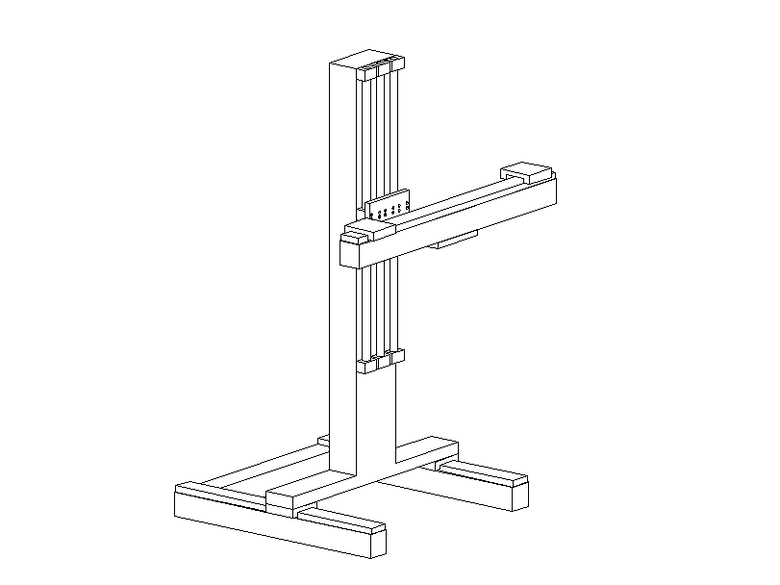
PIV MEASUREMENT AND NUMERICAL SIMULATION
Trigger
signal
3D Traverse
PULSE
A
B
Frame Grabber

8bit Image Data

Sync. Trigger signal

CCD Timing signal
CCD Cameras

Synchronizer
Optic arm

Flashlamp fire/
Q-switch signal

Laser
light sheet
Visualization Window

2-Head Nd-YAG Laser

Figure 1. Schematics of the PIV measurement system
For the comparison of the conventional duct system and the new duct system of the refrigerator, the PIV system as shown in Fig. 1 was used to measure the velocity distribution in each shelf and door basket. The PIV system consists of a 2-head Nd:YAG laser (max. 300 mJ/7ns pulse), lightsheet forming optics, a laser arm to direct the light source, a pulse synchronizer, and a 1K×1K CCD camera (30 frames/sec). Lubricating oil (Glycerin, SG-α 10G) was used with an atomizer to supply the seeding particles. Field-of-views of 120mm by 120mm were used to capture 50 particle images and calculate the mean velocity field.
The mean velocity field results of the upper shelf of the refrigeration compartment with the conventional duct system and with the new duct system are compared in Fig. 2. It can be seen that the flow induced by the conventional duct system and the new duct system show similar patterns. From these similar flow characteristics the two duct systems could be anticipated to show similar performance in the cooling of the shelf region.
(m/s)

(a) (b)
Figure 2. Mean velocity distribution of the upper shelf of the refrigeration compartment
(a) the conventional duct system, (b) the new duct system.

The mean velocity field results of the basket regions with the conventional duct system and with the new duct system are shown in Fig. 3. Due to the new duct system, the flow into the lower basket can be observed, and it was found to efficiently cool the region; effectively leading to a more uniform temperature distribution inside the refrigerator compartment.

(m/s)

(a) (b)
Figure 3. Mean velocity distribution of the basket region of the refrigeration compartment
(a) the conventional duct system, (b) the new duct system.

Also, a numerical analysis of the velocity and temperature distribution inside the refrigeration compartment was carried out using the commercial software FLUENT. The grid system was made with the body fitted coordinate, with the boundary condition as the average heat transfer coefficient calculated with a 30°C surrounding. The left wall is adjacent to the -18°C freezer compartment and the boundary condition was set according to its average heat transfer coefficient. The outlet velocity and temperature at each outlet were set as found by experiments. Figure 4 shows the velocity distribution at the center plane of the refrigeration compartment and temperature distribution at the wall of the refrigeration compartment with the new cooling duct system. From this result, we can find that the new duct system improve a uniform cooling performance of the refrigerator.

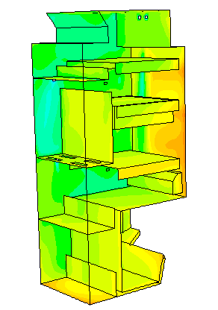
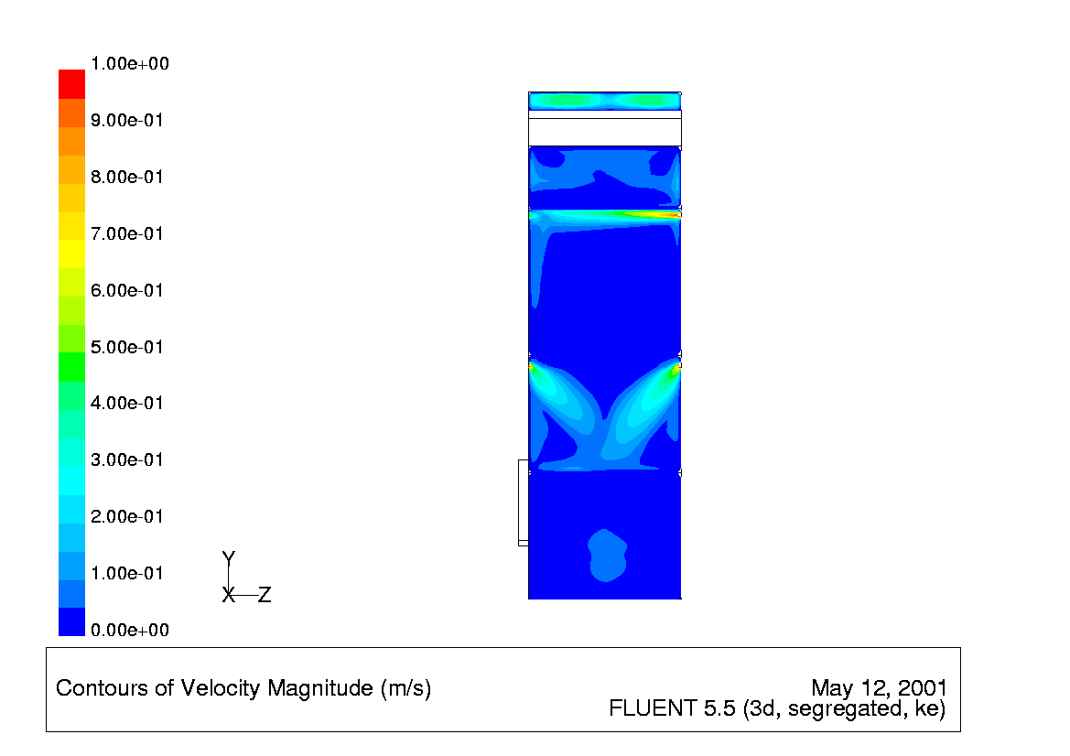
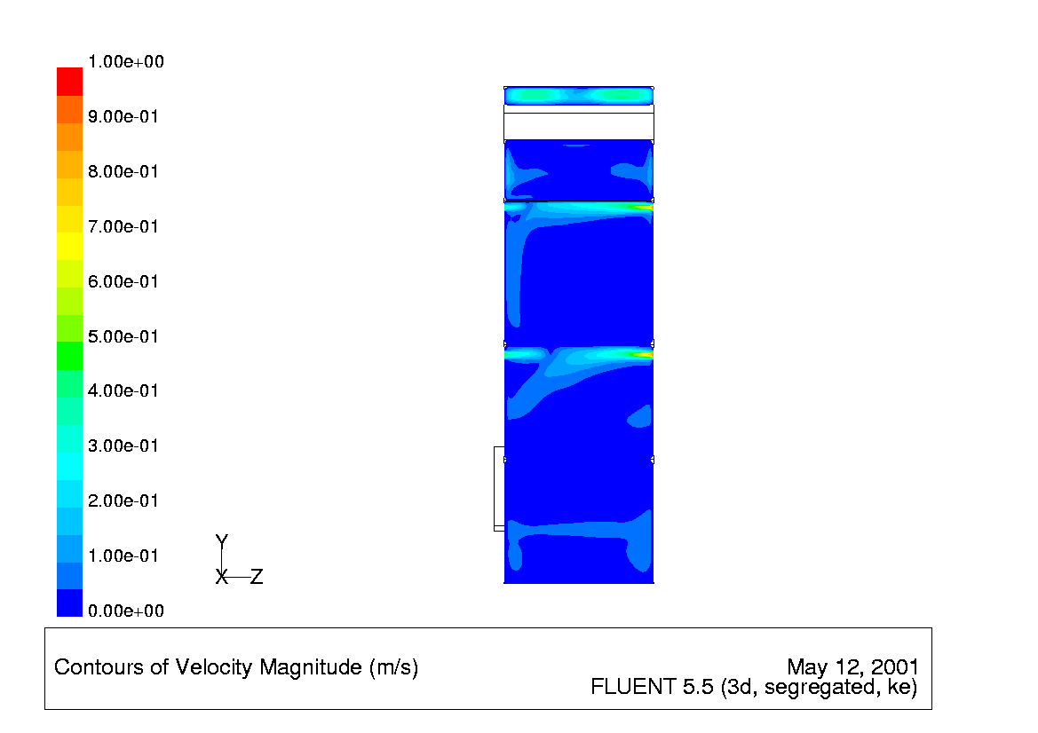
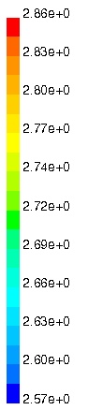

(a) (b)
Figure 4. (a) The velocity distribution at the outlet plane of the refrigeration compartment,
(b) The temperature distribution at the wall of the refrigeration compartment

CONCLUSION

The PIV technique and FLUENT was used to analyze the flow inside the refrigeration compartment with the conventional cooling duct system and the new cooling duct system. As a result, an overall uniform temperature distribution was successfully formed by installing additional ducts inside the left and right wall of the compartment, leading cooled air to flow toward the lower door basket.

