Propagation Patterns of MEG Interictal Spikes

George Zouridakis
Department of Computer Science
University of Houston, Houston, TX 77204, USA
A critical factor in determining outcome in patients suffering from medically intractable epilepsy that need to undergo surgical treatment is the accurate localization of an epileptogenic focus. In addition to the typical scalp electroencephalographic (EEG), video EEG, and intracranial recordings, a patient’s presurgical evaluation may now include magnetic source imaging (MSI), which is a completely noninvasive procedure that combines Magnetoencephalography (MEG) and magnetic resonance imaging (MRI) to localize the intracranial sources of epileptogenic activity. Almost exclusively, MSI studies image interictal spikes, the sources of which have been shown to be closely related to the focus of ictal activity.^{1,2} The MSI procedure is still under investigation, but preliminary results show that its high accuracy in identifying epileptogenic zones may eventually allow the replacement of certain invasive procedures currently in use. The objective of this study has been to define quantitative description of EEG and MEG spikes, as well as the time relationship between these two events, which would allow us to study the propagation patterns of seizure onset.

Methods
Subjects and Procedures

Nine patients (5 male and 4 female, age range 13-41 years) participated in this study. They suffered from medically difficult or intractable epilepsy characterized by focal onset of seizures and interictal spikes. We analyzed data obtained from the entire head simultaneously, including 148 channels of MEG and 21 channels of EEG activity. For each patient MRI scans were available in all three planes. The precise location of the surface measurements was determined electronically, and the MR images (anatomical data) were co-registered with the MEG measurements (functional data). The detailed procedure has been described elsewhere.³

Data Analysis

The MEG and EEG signals were sampled at 512 Hz, and band-pass filtered between 3 and 70 Hz, with a notch at 60 Hz. An off-line adaptive noise-cancellation procedure⁴ was used to remove ECG artifacts from the MEG records. All recordings were then visually inspected on a computer screen on an epoch-by-epoch basis, and only segments free of all artifacts (i.e., eye blinks, muscle activity, etc.) were selected for further analysis. For each subject, we could distinguish several artifact-free epochs containing well-defined spikes and sharp waves.
To quantify the time relationship between MEG and EEG spikes, we first identified the onset of an event in each modality, i.e., the latency of the peak on the MEG and EEG channel showing the spike first, and then we referenced these two values to the latency of the peak obtained after averaging the activity across all the MEG and EEG channels. Because of the great difference in scale between MEG and EEG channels, activity on all channels was normalized to unity amplitude, before averaging. We considered the onset of a spike for measuring latency differences, because it has been shown to be more stable⁵.

RESULTS

In these nine patients a total of 82 well-defined spikes and 49 sharp waves were detected on the MEG, EEG, or both records. Occasionally, a spike was seen on the MEG but not on the EEG channels, or vice versa. An example is shown in the top figure on the left. Additionally, topographic maps of MEG and EEG recordings showed that some of the epileptiform events propagated to the contralateral hemisphere within the same record (bottom figure on the left). In other cases, a propagation pattern within the same brain area was observed, like the one shown in the figure below, where a more posterior area of the right temporal lobe is activated first and then the activation spreads to the anterior tip of the temporal lobe. This is seen both on the topographic map and on the MRI.

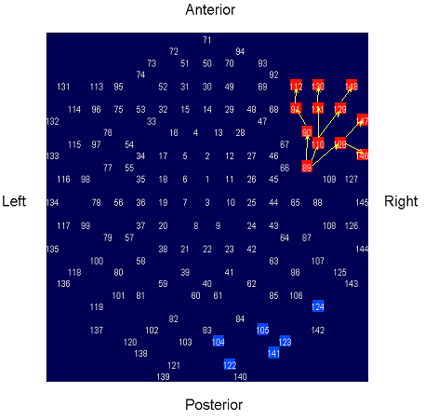
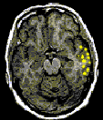
CONCLUSIONS

Our results show that MEG and EEG spikes may not always show simultaneously. Our particular analysis can be used as an extension of the standard MSI procedure to both identify epileptogenic areas noninvasively, and to obtain the spatiotemporal pattern of activation of the various areas involved in spike generation.

REFERENCES

- Barth D.S., The Neurophysiological Basis of Epileptiform Magnetic Fields and Localization of Neocortical Sources, J. Clin. Neurophysiol., Vol. 10, No. 1, 1993, pp.99-107
- Baumgartner C., MEG, EEG and ECOG: Discussion, in: Acta Neurol Scand, Suppl. 152, 1994, pp. 91-92
- Zouridakis G., Simos P.G., Breier J.I., Papanicolaou A.C. Functional hemispheric asymmetry assessment in a visual language task using MEG. Brain Topography, 11:57-65, 1998.
- Schoerken, P. "Comparison of MEG and EEG interictal activity in epilepsy patients." Diplomarbeit, Fach Hochschule, Lubeck, Germany, March 1999.
- Mallart R., Methods for time delay estimation between EEG signals: A critical valuation, Electroencephalography and epilepsy, 1988, pp. 1-96

