Visualisation of Bubble Plume Behaviour in Stratification

Toru Sato*, Kei Sato*, Atsuhiro Ishikawa* and Norikazu Nakashiki**
*Department of Environmental and Ocean Engineering, University of Tokyo
7-3-1 Hongo, Bunkyo-ku, Tokyo 113-8656, Japan
** Central Research Institute of Electric Power Industry
1646 Abiko, Abiko-shi, Chiba 270-1194, Japan

Abstract

Air and CO₂ bubble plumes in stratified water were studied experimentally and numerically. To understand plume behaviour of droplets or bubbles in the ocean is important in marine environmental engineering, such as CO₂ ocean sequestration, where liquid CO2 is injected in the form of droplets, and de-stratification in enclosed seas by using a bubble generator.

A desktop-sized tank (0.45m cubic) was used for no-background-flow conditions in salt stratification and a large circulation tank of thermally stratified water was for investigating the effect of inflow. Digital video images are taken to measure bubble size and to observe the plume dynamics in stratification, with changing gas species (air and CO2), gas flow rates, and stratification intensities. The plume is visualised by injecting a dye (fluorescein sodium) just above the bubble generator in the case of air and by dissolving a pH-indicator (methyl red) in advance in the case of CO2. Fig. 1 denotes typical images of the plumes of air and CO2 bubbles, respectively. In Fig. 1(b), CO2 bubbles become very small due to dissolution and move together with stratified water to more extent than air bubbles do and, consequently, the plume width is seems to be wider than that in Fig.1(a).

The mechanism of bubble plume behaviour in stratified water is that bubbles form a rising plume, entraining surrounding water, which peels out from the plume at some depth and starts sinking because of the density difference in stratification, and the peeled water sinks until it comes to some depth where its density is equal to that of the ambient stratified seawater, then, intrudes on the horizontal plane as gravity current. The peeled water was visualised by measuring the bubble movement by PIV in Fig. 2, where one can see downward flow and ring vortices around the plume.

When there is inflow, plume is tilted and the intrusion depth is influenced. Experiments were conducted by using the stratified circulation tank (the measurement channel size: 20m×2m×2m). Linear distribution of temperature and constant velocity profile were attained well. Figs. 3 and 4 denote typical images of bubbles and dye behaviour, respectively. The dye was injected just above the bubble generator to follow the flow induced by the rising bubble plume. Main flow comes from the left hand side in Fig. 4. The dye peels at several depths and intrudes in separate layers in stratification. The behaviour of plume and consequent intrusion is quite complicated when having main flow.

(a)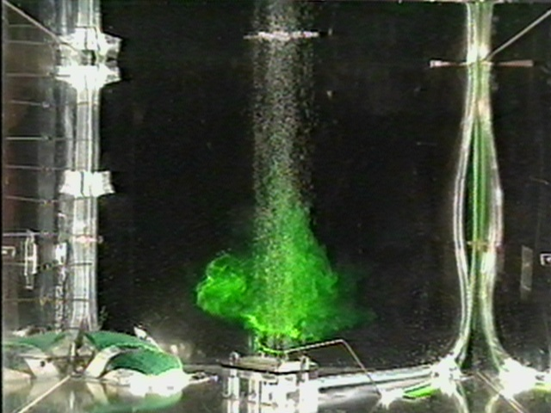(b)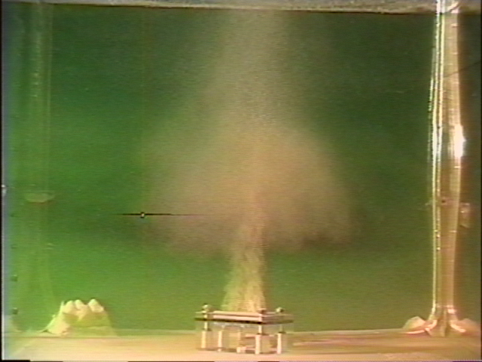
Fig. 1 Photograph of Bubble Plume and Intrusion. (a) Air. (b) CO2.

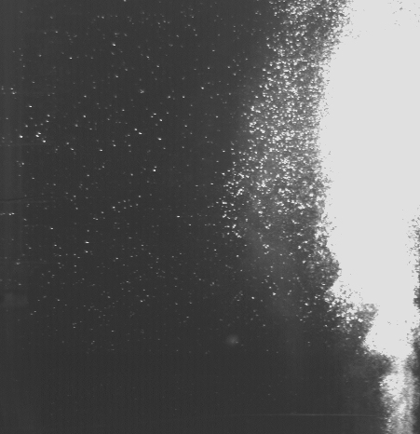
Fig. 2 Bubble Velocity Measured by PIV near Bubble Plume

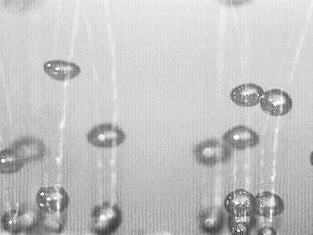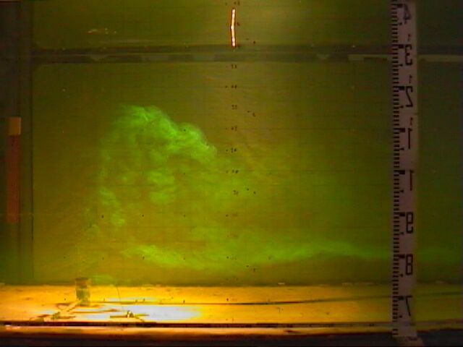
Fig. 3 Photograph of Rising Bubbles. Fig. 4 Photograph of Dye Injected at Bubble
Generator in Stratified Circulation Tank.

