VISUALIZATION OF THE DNA
FLOW IN THE COMET ASSAY
B. Smolka A. Swierniak M. Szczepanski

Dept. of Automatics Electronics and Computer Science
Silesian University of Technology,
Akademicka 16 Str., 44-101 Gliwice, POLAND
bsmolka@ia.polsl.gliwice.pl

Keywords: image processing, segmentation, binarization, noise reduction
Abstract
The single cell gel electrophoresis, called comet assay is a very sensitive method of detecting the DNA strand breaks at the level of single cell. This method allows the measurement of the rate of initial DNA breaks and rejoining and indicates the repair capacity of cells. Our interest is the application of the comet assay as a predictive method of evaluating the individual radiosensitivity of cancer patients. In this paper we introduce a quite new method of the visualization of the comet tail. To our knowledge it is the first technique capable of determining the comet tail shape in form of a binary image, which allows not only the calculations of all relevant comet parameters, but also enables the description of the comet shape and its structure.
1 Introduction
So far the images of damaged cells, showing the DNA which migrated under the influence of the electric field were thresholded using black and white or pseudo-colour representation and on this basis the comet coefficients were calculated. The analysis of the available commercial image processing systems designed for the evaluation of comets and the so called self made software used in many laboratories ( the most popular are macros written for the NIH Image) and the review of the literature [1-19] leads to the following conclusions :
• The length of the comet tail and other comet parameters which describe the amount of the DNA that migrated from the cell are defined in different ways, so that the comparison of the results obtained in different research centres is difficult and sometimes impossible.
• As can be easily observed the comet head is surrounded by some kind of a shadow called halo, and this comet feature is not carefully considered, when calculating the comet parameters, which can lead to severe errors.
• The shape of the comet seems to be an important feature, which contains relevant information concerning the damaged cell properties. The commonly used methods are not able to detect the comet tail as a topological object and no measurement of the comet shape parameters were so far possible.
The method presented in this paper is to our knowledge the first technique able to extract and visualize the comet tail, without any thresholding performed either by the computer system or by the operator and it is also the only method which can extract the tail as a topologically connected and homogeneous binary object.

2. NEW METHOD OF COMET TAIL VISUALIZATION
In the paper we use a probabilistic approach to the problem of comet tail extraction. The algorithm introduced here is based on a model of a virtual particle, which performs a random walk on the image lattice. It is assumed, that the probability of a transition of the walking particle from a lattice point to a point belonging to its neighbourhood is determined by a Gibbs distribution, defined on a specified neighbourhood system [20, 21].
Let the image be represented by a matrix F of size $N_{r},N_{c}$, and let us assume the eight-neighbourhood system on the image lattice. Additionally let us introduce a virtual particle which can visit its neighbours or stay in its temporary position.
In this work it was assumed, that the particle moves on the image lattice with probabilities derived from the Gibbs distribution formula

$P_{(i,j)a(k,l)}=\frac{\text{exp}\left\{β(V(i,j)−(k,l)\right\}}{Z},$ $Z=\sum_{(m,n)»(i,j)}{\text{exp}\left\{β(V(i,j)−V(m,n)\right\}}$,
where $(i,j)»(k,l)$ denotes the neighbourhood relation, V(i, j) is the potential energy of the pixel (i, j) and β plays the role of the inverse of temperature of the statistical system. In this work V(i, j) is represented simply by the gray scale value F(i, j) of the point (i, j).
Let us now assume, that the value of the centre pixel (i, j) is set to zero, which means that F(i, j)=0. Then, the intensity of (i, j) is not taken into consideration, while calculating the probability $P_{(i,j)a(k,l)}$. Under this assumption
The probability that the virtual particle will stay at its current position, and in this way the probability that the particle will not escape from (i, j) is
Assigning to each image point the probability that the randomly walking particle will stay at its current position leads to a new image, which after the normalisation can be treated in an iterative manner. The successive iterations, lead as can be easily shown, to a binary image showing the image of the comet head and its tail. As can be seen in Fig. 1 and 2, the processed comet image is a closed object with perfectly defined boundary. All the images were obtained using the same parameter β of the Gibbs distribution. Having the information about the region which can be classified as the comet, different calculation of the comet tail parameters can be performed.
3. CONCLUSIONS
In our report we propose, a reliable method of comet tail and head extraction. This new method of the visualization of the DNA flow from the cell kernel is fast and reliable, it is not sensitive to noise and acquisition parameters. The authors are planning the implementation of the new algorithm into the comet assay software, so that the process of calculating the different comet parameters can be done automatically.
4. REFERENCES
[1] P.L. Olive DNA damage and repair in individual cells: applications of the comet assay in radiobiology, Int. J. Radiat. Biol 1999, 75, 4, 395-405, 1999
[2] Bocker W., Baugh T., Muller W. U. Streffer C. Image analysis of comet assay measurements, International Journal of Radiation Biology, 72, 449-460, 1997
[3] Collins A.R., Duxinska M., Franklin M., Somorovska M., Petrovska H. Duthie S., Fillion S., Panayiotidis M., Raslova K., Vaughan N. Comet assay in human biomonitoring studies : reliability, validation, and applications, Environ. and Mol. Mutagenesis 30, 139-146, 1997
[4] Malyapa R.S., Chen Bi, E.W. Ahern and J. L. Roti Roti Detection of DNA damage by the alkaline Comet Assay after exposure to low-dose gamma radiation, Rad. Res. 149, 396-400, 1998
[5] Hellman B. , Vaghef H. , Bostrom B. The concepts of tail moment and tail inertia in the single cell gel electrophoresis assay, Mutation Research 336, 123-131, 1995
[6] Poeller F., Bauch T., Sauerwein W., Boecker W. ,Wittig A. , Streffer C. Comet assay study of DNA damage and repair of tumour cells following boron neutron capture irradiation with fast d(14)+ Be neutrons, Int. J. Radiat. Biol., 70, 5, 593-602, 1996
[7] Oestling O, Johanson K.J. Microelectrophoretic study of radiation-induced DNA damage in individual mammalian cells, Biochemical and Biophysical Research Communications, 123, 291-298, 1984
[8] Oestling O, Johanson K.J. Bleomycin, in contrast to gamma irradiation, induces extreme variation of DNA strand breakage from cell to cell, International J. of Rad. Biology, 52, 683-691
[9] Olive P.L. Banath J.P. Durand R.E. Heterogenetity in radiation-induced DNA damage and repair in tumor and normal cells using the comet assay, Radiat. Research 122, 86-94, 1990
[10] Collins A. R. Workshop on single cell gell electrophoresis (the comet assay). Mutagenesis, 7, 357-358, 1992
[11] McKelvey Martin V. , Green P. , Schmezer B., Pool Zebel M., De Meo, Colllins R. Genotoxicity of potassium permanganate in acidic solutions, Mutations Research 260, 295-306, 1993
[12] McCarthy P. J. , Sweetman S. F. , McKenna P. G. McKevey-Martin V.J. Evaluation of manual and image analysis quantification of DNA damage in the alkaline comet assay, Mutagenesis, Vol. 12, 209-214, 1997
[13] McKelvey-Martin V.J. Green M.H.L. Schmer P Pool-Zobel B.L DeMeo M.P. Collins A. The single gel electrophoresis assay (comet assay): a european review, Mutat. Res., Vol 288, 47-63, 1993
[14] Anderson D., Yu T.W., McGregor D.B. Comet assay responses as indicators of carcinogen exposure, Mutagenesis, Vol. 13, 539-555, 1998
[15] Wojcik A. , Sauer C., Zolzer F., Bauch T., Muller W.U.
Analysis of DNA damage recovery process in the adaptive response to ionizing radiation in human lymphocytes, Mutagenesis Vol. 11, 291-297, 1996
[16] Anderson D, Dobrzynska M.M., Basaran A.A. Yu T.W. Effect of various genotoxins and reproductive toxins in human lymphocytes and sperm in the comet assay, Taratogen. Carcin.. Mutagen. Vol. 17, 29-43, 1997
[17] Ashby J. , Tinwell H., Lefevre P.A, Browne M.A. The single cell electrophoresis assay for induced DNA damage (comet assay) : measurement of tail length and moment. Mutagenesis, Vol. 10, 85-90, 1995
[18] Hughes C. M. , Lewis S. E. M. McKelvey-Martin V. J. Thompson W. Reproducibility of human sperm DNA measurements using the single cell gel electrophoresis assay, Mutat. Res. Vol. 347, 261-268, 1997
[19] Henderson L. , Wolfreys A., Fedyk J., Bourner C., Windebank S. The ability of Comet assay to discriminate between genotoxins and cytotoxins, Mutagenesis Vol 13, 89-94, 1998
[20] Smolka B., Wojciechowski K. A new method of texture binarization, Lecture Notes on Computer Science, 1296, 629-636, 1997
[21] Smolka B. , Wojciechowski K. Contrast enhancement of badly illuminated images, Lecture Notes on Computer Science, 1296, 271-278, 1997

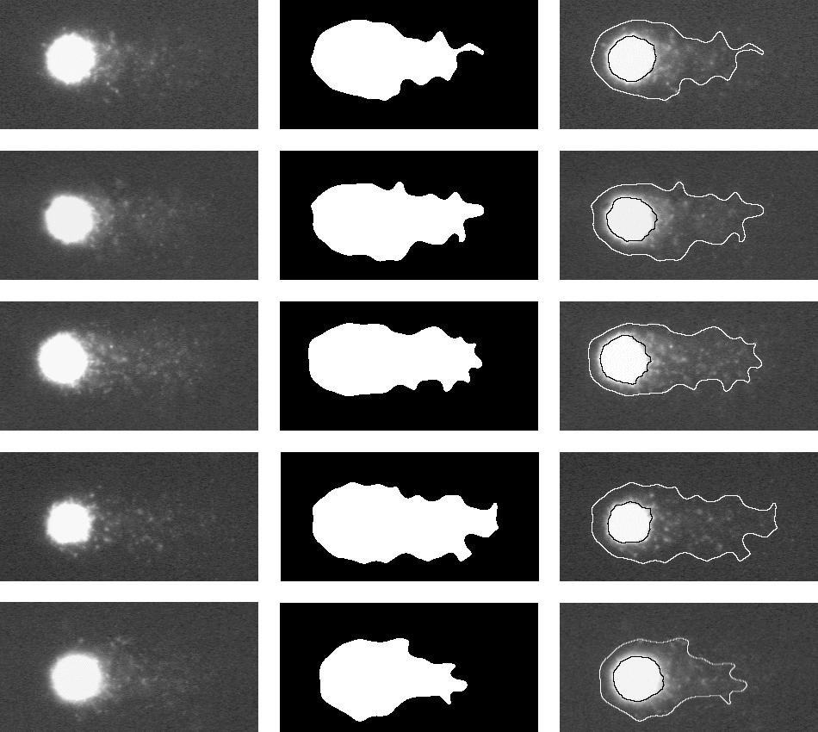

Fig. 1 The results of comet tail and head extraction, with the use of the new method presented in the paper. On the left the original comet assay images, beside the binarized versions and the superposition of the boundaries and original images.
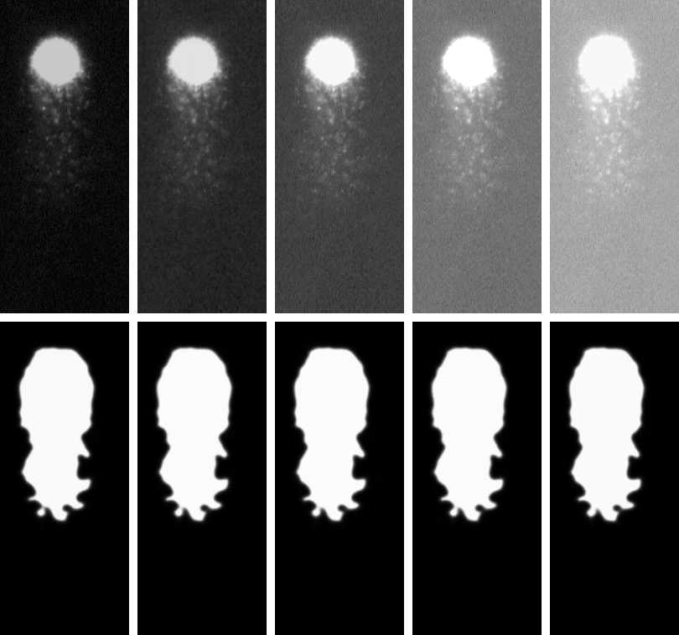
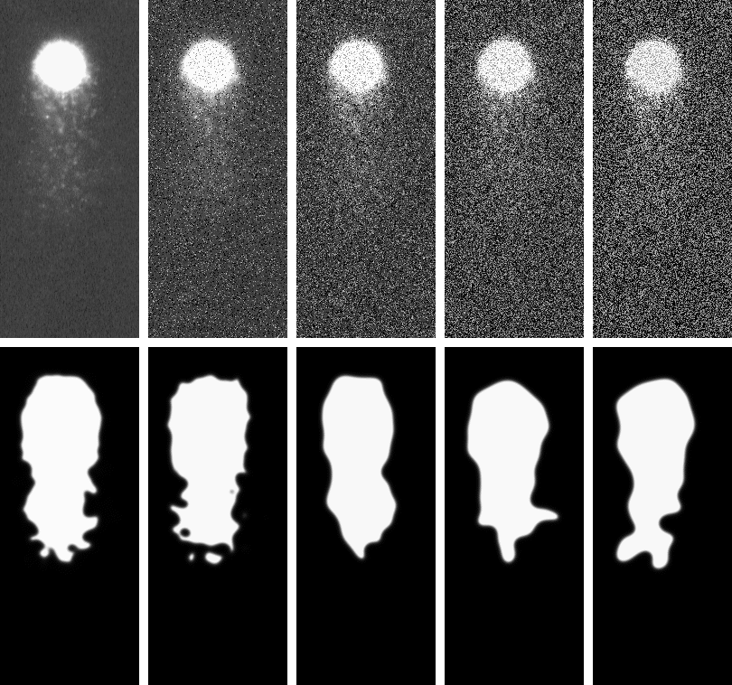
Fig. 2 The results of comet tail and head extraction, with the use of the new method presented in the paper, at different image acquisition parameters (illumination and noise).

